
RAMAIAH
INSTITUTE OF TECHNOLOGY
USN | 1 | M | S

(Autonomous Institute, Affiliated to VTU)
(Approved by AICTE, New Delhi & Govt. of Karnataka) Accredited by NBA & NAAC with ‘A’ Grade

SEMESTER END EXAMINATIONS – JANUARY 2018

Course & Branch | : | B.E. : Electrical and Electronics Engineering. | Semester | : | V
Subject | : | Control Systems | Max. Marks | : | 100
Subject Code | : | EE52/EE502 | Duration | : | 3 Hrs

Instructions to the Candidates:
- Answer one full question from each unit

 |  | UNIT- I
1. | a) | What is the significance of presence of feedback in control system? Explain with at least two example. | CO1 | (06)
 | b) | Define transfer function? And Briefly explain the need for modeling of a system. | CO1 | (06)
 | c) | Obtain the transfer function of the following circuit diagram Fig.1(c).  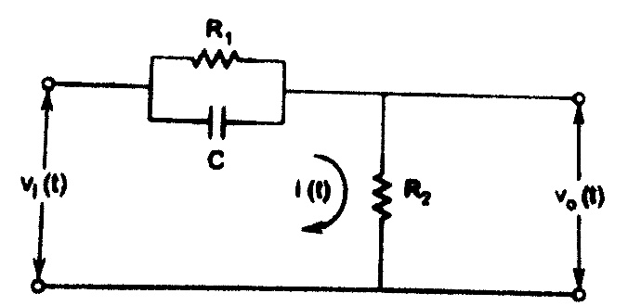  Fig.1(c) | CO1 | (08)
2. | a) | Obtain the transfer function of the following system given in Fig. 2(a). Also obtain the equivalent circuit model by i) F-V analogy and  ii) F-I analogy.  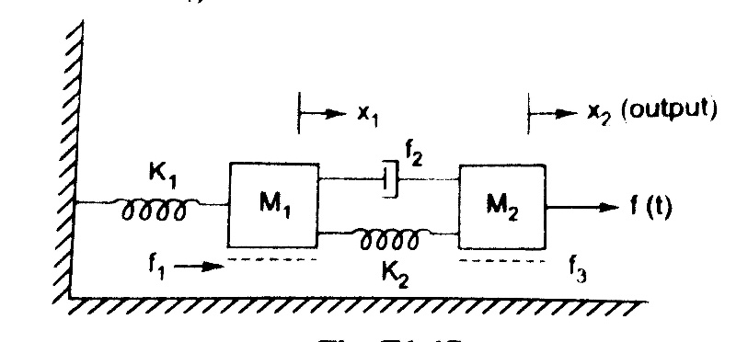  Fig.2(a) | CO1 | (12)
 | b) | Derive transfer function of field controlled separately excited DC servo motor. | CO1 | (08)
 |  | UNIT- II
3. | a) | Obtain the TF of the following Block diagram in Fig.3(a) using SFG technique.  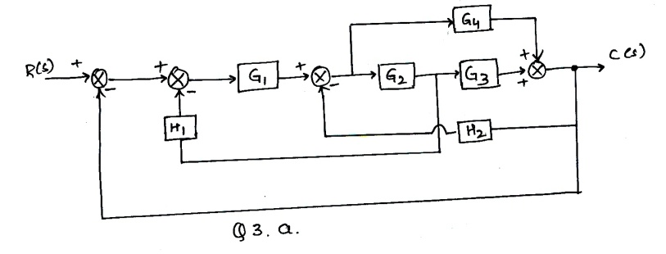 | CO1 | (08)
 | b) | Determine the (i) time response specifications and (ii) expression for output for unit step input (y → output, x → input) to a system having equations as follows 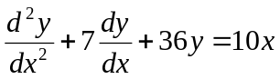 | CO2 | (04)
 | c) | A second order system is represented by the transfer function, 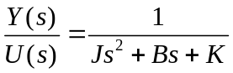. A step input of 10Nm is applied to system and results are,  - % 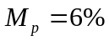  - 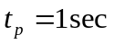  - The steady state value of output is 0.5 radians.  Find the values of J,B and K. | CO2 | (08)
4. | a) | The overall t.f. of a unity feedback control system and it is given as  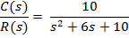  - Find  - Determine the steady-state error if the input is | CO2 | (10)
 | b) | For a system , find the value of K to limit the steady-state error to 10 when the input to the system is . | CO2 | (06)
 | c) | Define the meaning of Stable System? If a closed loop TF is having zero at -2 and poles at -3, +5, whether system is Stable? Justify with its time response behavior. | CO3 | (04)
 |  | UNIT- III
5. | a) | Sketch the root locus plot and find stability for a unity feedback system whose OLTF is given as G(s)=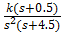. | CO3 | (10)
 | b) | Examine the stability of the given equations using Routh’s stability criterion: | CO3 | (10)
6. | a) | According to R-H stability criteria, how can you analyse the stability of the control system? | CO3 | (06)
 | b) | A unity feedback control system has an open loop transfer function 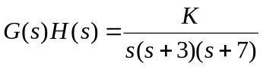  Draw the root locus plot of the system by calculating the following:  - Centroid, number and angle of asymptotes  - Breakaway point if any  - The value of K and the frequency at which the root locus cross the 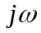axis. | CO3 | (14)
 |  | UNIT- IV
7. | a) | Sketch the Nyquist plot and determine the stability of the system having 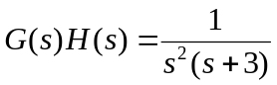 . | CO4 | (14)
 | b) | Define gain margin and phase margin. Explain the significance of these terms to find the closed-loop system stability. | CO4 | (06)
8. | a) | The open loop TF of a unity feedback system is given by 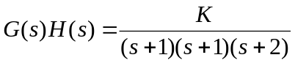 Using Nyquist criterion, Comment on stability. | CO4 | (14)
 | b) | Draw the polar plot of:  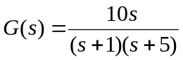 | CO4 | (06)
 |  | UNIT- V
9. | a) | Determine the values of gain k for the following open-loop transfer function so that  - The gain margin is 15 dB  - Phase margin is 60°  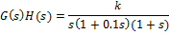 | CO5 | (14)
 | b) | Explain the need for designing of a compensator with one practical example. | CO4 | (06)
10. | a) | Obtain the transfer function from the following bode diagram in Fig.10(a).  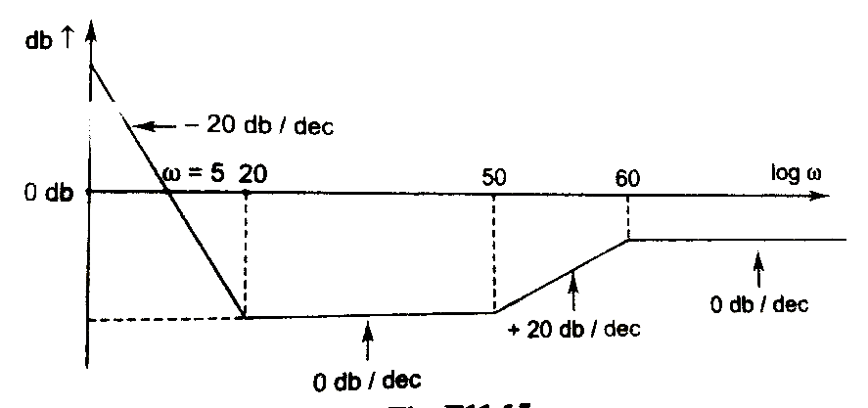  Fig.10(a) | CO1 | (12)
 | b) | Obtain the transfer function of RC lead compensator, for 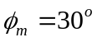and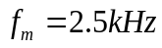. Assume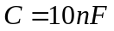. Also find the corner frequencies. Using vector diagram show that output waveform leads the input. | CO1 | (08)

****************

